Memories from Wilfrid Gordon McDonald Partridge by Mem Fox

A Memory is… | Wilfrid Gordon found….

Optional pictures to use in place of print.
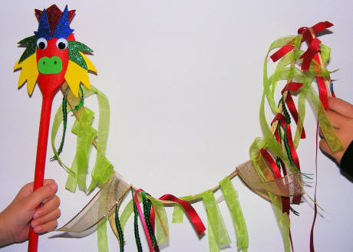

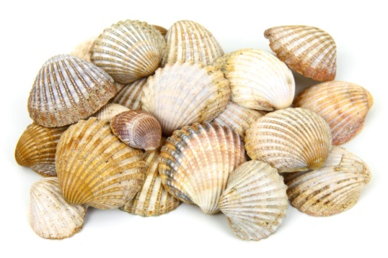

Name: _____________________________

Writing Planner

A Memory is… | I remember…

Pictures for anchor chart:

