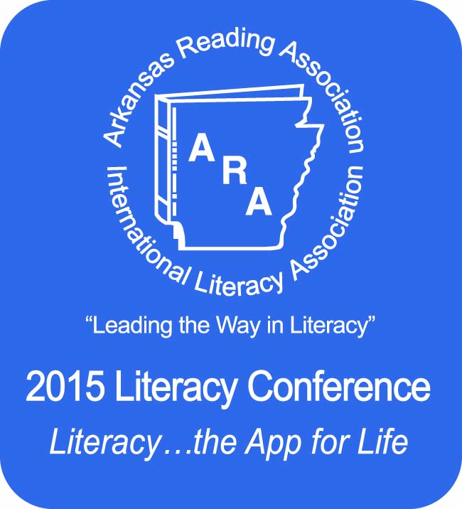
http://www.arareading.org/ARA-2015-Literacy-Conference

November 19-20, 2015

The annual Arkansas Reading Association’s Literacy Conference is scheduled for November 19-20, 2015, in Little Rock, Arkansas, at the Statehouse Convention Center and Little Rock Marriott Hotel. We are expecting 1000 literacy educators to attend the 2015 conference. Exhibits will be located in Governor’s Hall II, Statehouse Convention Center, #1 Statehouse Plaza.
The cost of a line booth is $400.00 and a corner booth is $450.00. Payment includes one 6’ table, two chairs, and a standard sign identifying your company. Payment should accompany the contract form below or may be paid with a credit card on our website. If payment is not included, the booth contract space will be held for 14 days before reverting to the end of the request list.
A cancellation of booth space request received prior to October 15 will be entitled to a refund equal to 75% of the total booth rental fee. There will be no refund for cancellation requests received after October 15.
For information about use of internet and phone hookups, contact Kitty Lane (klane@littlerock.com) at the Statehouse Convention Center (501) 376-4781. Additional tables and carpet can be ordered from Sunbelt Convention Services online at www.sunbelt4u.com; via email (sunbelt4u@sbcglobal.net); or by phone at 501-244-9955.
Exhibitors can set up between 3:00 p.m. and 8:00 p.m. Wednesday, November 18, and 7:00 a.m. to 8:00 a.m. Thursday, November 19.
The Little Rock Marriott will serve as the ARA Literacy Conference hotel. To receive the conference room rates call 1-800-831-4004 or book online through our web page conference link.
The exhibit hall schedule:
Thursday, November 19 8:00 a.m. - 4:30 p.m.
Friday, November 20 8:00 a.m. - Noon

If you have questions regarding exhibits:
E-mail: Caroline Schenk at caroline@arareading.org

Caroline Schenk,
ARA Exhibit Chair

Additional information, including a program proposal form and an online booth order form, is posted on www.arareading.org.

