Teaching Vocabulary So Kids Will Beg for More!
Arkansas Reading Association
November 19, 2015
Brenda J. Overturf, Ed. D.
bjoverturf@gmail.com/www.bjoverturf.com

Characteristics of Effective Vocabulary Instruction
- Does not rely on definitions.
- Represents knowledge of words in linguistic and nonlinguistic ways.
- Involves the gradual shaping of word meanings through multiple exposures.
- Teaches word parts to enhance understanding of terms.
- Discusses terms.
- Plays with words. (Marzano, 2004)

Vocabulary Cycle Plan:
- Introduce a small number of words in context. Students predict word meaning and make connections to their own lives. Begin vocabulary journals.

- Use reference materials to add synonyms/examples and antonyms/non-examples. Complete vocabulary journals.

- Plan for several days of engaging activities with the vocabulary words, their synonyms, and their antonyms. Use music, art, technology, drama, writing, games, graphic organizers, children’s literature, etc., to make sure students have many verbal and nonverbal experiences with the words. Also help students learn to analyze roots and affixes of multisyllabic words.

- Hold a Vocabulary Party (hint: it’s a secret review!).

- Assess using a combination of cloze passages and multiple choice questions. Make sure to include words students have studied in previous vocabulary cycles.

Vocabulary Journal Entry--Frayer Model
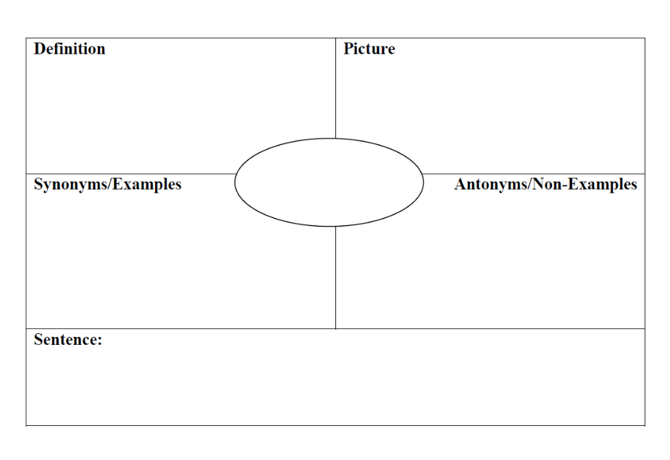

Word Colors:
- Choose a multisyllabic word.
- Write the word on one side of the card.
- Choose a color to represent the word you wrote.
- Lightly color over the word on the card using the color you chose.
- On the other side of the card, write a sentence using at least 7 words explaining why the color represents the word.

Show Me:
- Choose a vocabulary word.
- With a partner, create a hand gesture to represent the word.
- Demonstrate the gesture for the rest of the group.
- After the group tries to guess the word you chose, explain your thinking.

From Word Nerds: Teaching All Students to Learn and Love Vocabulary
Stenhouse, 2013
Brenda J. Overturf, Leslie H. Montgomery, & Margot Holmes Smith

